

Year 7 Algebra Investigation
2015
Term 1, Semester 1
Instructions:
This investigation consists of three parts.
The first task will be completed in class with your teachers.
The second will be completed at home in your own time using the information you gathered in class. It will account for 30% of this investigation
You will be able to ask your teacher questions about the second task you completed at home before sitting an in class validation.
The validation test will expand on what you learnt in the first two tasks and will account for 70% of the mark for this investigation
You will need the following items:
- Ruler
- Calculator
- Pen/Pencil

Name:________________________________
Investigation Due Date:__________________ Mark:____/ 10 x 30 = _____
Validation Test:________________________ Mark:____/___ x 70 = _____

TASK 1 – MATCHSTICK TRIANGLES

Consider the following pattern with matchsticks.
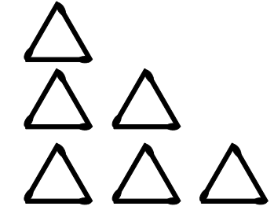
Row 1

Row 2

Row 3
Draw the next two rows of triangles
Row 4

Row 5

t (number of triangles) | 1 | 2 | 3 | 4 | 6 | 20 | n
m (number of matches) | 3 | 6
Use the diagram above to help you complete the table below.
You may draw additional sketches if you would like to. You should leave the columns 20 and n until you have completed the information sections. Then come back to fill in the columns.

Describe in your own words what is happening in the pattern above

______________________________________________________________________________________________________________________________________________________________________________________________________________________________________________________

Information section

Flow Diagram
One way to represent the relationship between the number of triangles and the number of matches is with a flow diagram, like the one given below.
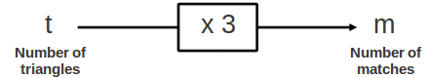

The flow diagram shows us that if we multiply the number of triangles by three we find the number of matches in the construction.

This means that this pattern has a formula:
t x 3 = m

Describe using the example above how you could work out that the pattern flow chart or formula is t x 3 and not t x 2 +1.
___________________________________________________________________________
___________________________________________________________________________
___________________________________________________________________________

Information Section

Working in reverse
Working in reverse we have the flow diagram below which shows how to work out the number of triangles that can be formed given the number of matches.
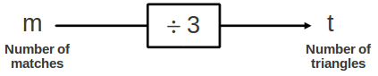
The flow diagram shows us that if we divide the number of matches by three we get the number of triangles we could create in the construction.
How did you know that when you go backwards we should divide instead of multiply?
_________________________________________________________________________________________________________________________________________________________________________________________________________________________________

Write the formula for the determining the number of triangles in this pattern.

Completing the following table using the information above:
t (number of triangles) | 45 |  | 15
m (number of matches) |  | 600 |  | 153

TASK 2 – MATCHSTICK HEXAGONS

Consider the following pattern created with matches.

Row 1
Row 2

Row 3

Row 4
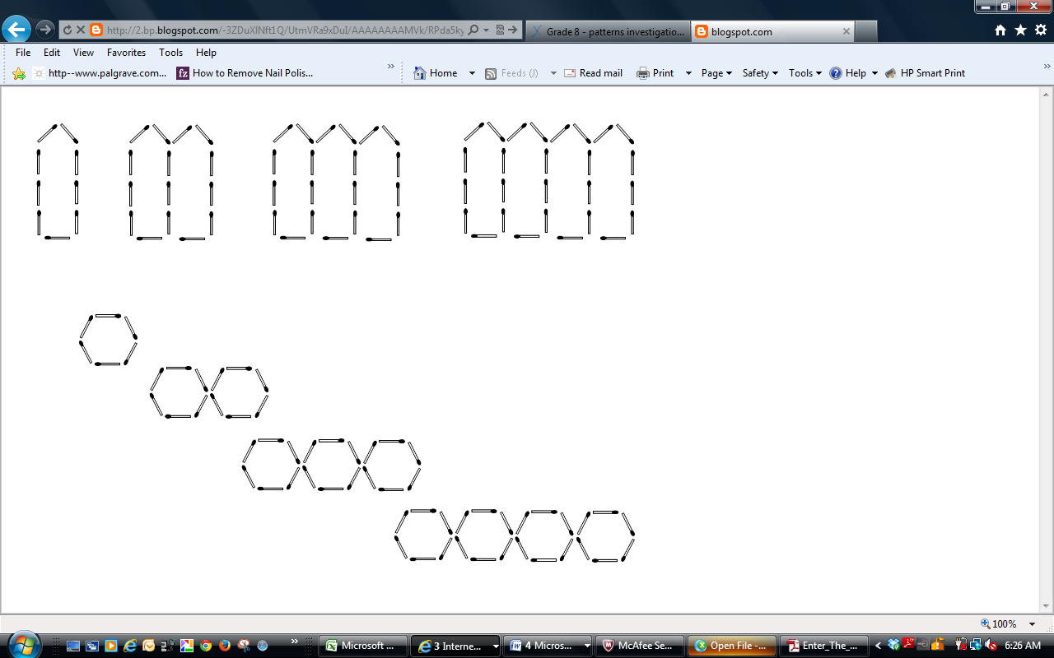

Draw in the next row. [1]
Row 5

Complete the following table. Use the diagram to help you. You may draw additional diagrams to help you. [2.5]
h (number of hexagons) | 1 | 2 | 3 | 4 | 6 | 20 | n
m (number of matches) | 6 | 12

Describe in your own words what is happening in the pattern above [1]
_________________________________________________________________________________________________________________________________________________________________________________________________________________________________
Complete the following flow diagrams, representing the relationship between the number of hexagons and the number of matches. [2]
h
number of hexagons
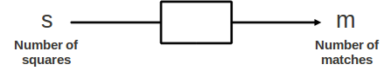
h
number of hexagons

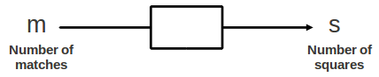
Write down the formula for calculating the number of matches (m) required if we want to create a certain number of hexagons (h). [1]

Write down the formula for calculating the maximum number of hexagons (h) we could create if we have a certain number of matches (m). [1]

Complete the table. Use your formulae or flow charts to assist you. [1.5]
h (number of hexagons) | 36 |  | 55
m (number of matches) |  | 480

